**April Newsletter 2019**

|  |
| --- |
| **What’s happening this month?**  April 19th– Good Friday  April 22th –Easter Monday  Our Centre will be closed these two days. We will open from Tuesday April 23rd |

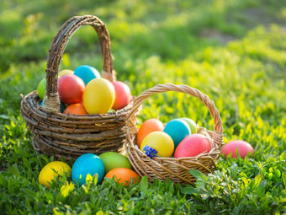

**What we enjoyed doing in March**

I hope you are all enjoying the nice weather outside. We are starting to enjoy outdoor time by practicing to walk on ground, trying to push the pushing toys, working on our fine motor skills by playing in sand box using shovels and buckets and throwing balls to each other’s.

We celebrated St. Patrick’ day, most of the staff and children wear green colors. We explored to paint, glue, stick and scribbled on green and white colours St. Patrick’s day, Shamrock shape construction paper foam.

We explored to paint with Q-tips, stick foam shapes on foil, glue mosaic tiles on paper bags and bingo dabber on coffee filters, glue St. Patrick shamrock, and glitter! We learned to hold the tools, spread the glue and enjoyed to touch our sticky and painted hands after all and also we glued the winter and spring pattern on paper. We also enjoyed pushing large toys and kicked and bounced the balls.

**What we enjoyed doing in September**

George, the co-op student from the high school, played his guitar for us. We practiced clapping our hands, making sounds by shaking the bottles and bells and banging with drum sticks on drum, used our muscles to stomp our feet as we danced.

We were so interested in going in and out through the tunnel, used our arms to push the big car, shopping cart and stroller, explored painting with q-tips, practiced to scoop flour, rice and more! We also liked to scribble with crayons and chalks, glue feathers, pompoms on papers by adding more and more to learn everyday!

**Upcoming Birthdays**

Enoch is turning 1 on October 2nd, 2016.

Jeronimo is turning 1 on October 8th,2016.

We wish them to happy birthday!

**What we enjoyed doing in September**

George, the co-op student from the high school, played his guitar for us. We practiced clapping our hands, making sounds by shaking the bottles and bells and banging with drum sticks on drum, used our muscles to stomp our feet as we danced.

We were so interested in going in and out through the tunnel, used our arms to push the big car, shopping cart and stroller, explored painting with q-tips, practiced to scoop flour, rice and more! We also liked to scribble with crayons and chalks, glue feathers, pompoms on papers by adding more and more to learn everyday!